Module 1: Overview of IT Industry

- What is program?
- A program is a set of instructions given to a computer to do a specific work.
These instructions are written in a programming language.
LAB EXERCISE:
Write a simple "Hello World" program in two different programming languages of your choice. Compare the structure and syntax.
- C Language
#include <stdio.h>
int main() {
printf("Hello World");
return 0;
}
THEORY EXERCISE:
Explain in your own words what a program is and how it functions.
- A program is a group of instructions that tells a computer what work to do.
These instructions are written using a programming language.
First, a programmer writes the program.
Then the computer changes these instructions into a form it can understand.
After that, the computer follows the instructions step by step. The program may take input from the user, process the data, and then give output.
In this way, a program helps the computer complete a task properly.
- What is Programming?
- Programming is the process of telling a computer what to do.
In programming, we write instructions so the computer can perform a task.
THEORY EXERCISE:
What are the key steps involved in the programming process?
- Problem definition, analysis, algorithm design, coding, testing, etc. are involved in programming process
- Types of Programming Languages?
- There are 4 types of programming language
- Procedural programming language
- Object oriented programming language
- Logical programming language
- Functional programming language
THEORY EXERCISE:
What are the main differences between high-level and low-level programming languages?
- High-level programming languages are easy for humans to read and understand.
They use simple words and are closer to normal English.
These languages help programmers write programs quickly.
Examples are Python, Java, C++, and JavaScript.

- Low-level programming languages are closer to machine language.
They are hard for humans to read and write.
These languages work directly with computer hardware.
Examples are machine language and assembly language.

- World Wide Web & How Internet Works
- World Wide Web (WWW):
The World Wide Web is a collection of web pages and websites.
These pages are connected to each other through links.
We can open and view them using a web browser like Chrome or Firefox.
The web allows us to see text, images, videos, and other information online.
- How the Internet Works:
First, we type a website name in the browser.
The request is sent to the Internet Service Provider (ISP).
The website name is changed into an IP address.
Then the request reaches the server where the website is stored.
The server sends the data back.
Finally, the browser shows the website on the screen.
LAB EXERCISE:
Research and create a diagram of how data is transmitted from a client to a server over the internet.
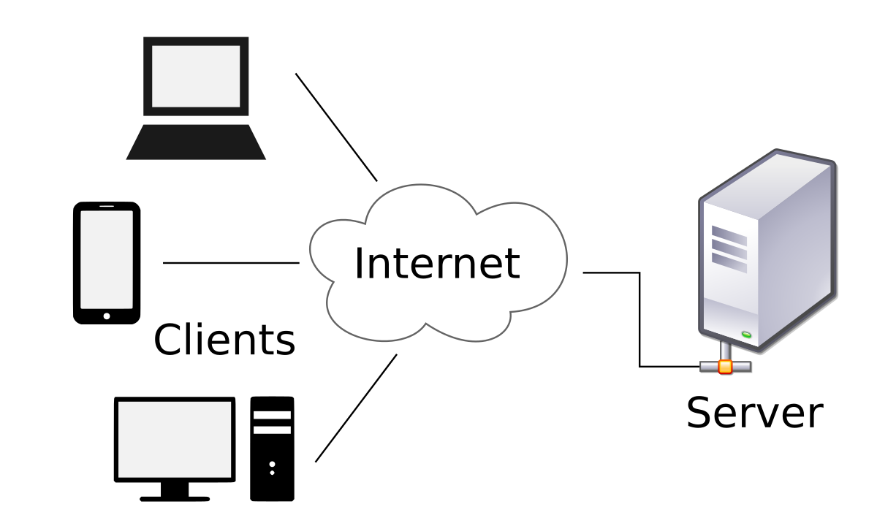
THEORY EXERCISE:
Describe the roles of the client and server in web communication.
- The client is the device or software that sends a request.
It asks for information from the internet.
Examples of clients are web browsers, mobile apps, or computers.
- The server is a powerful computer that stores websites and data.
It receives the request from the client.
After processing the request, the server sends the required information back to the client.

